C - Stacks, Queues - LIFO, FIFO

stacks and queues in C are data structures that can be implemented using either arrays or linked lists.
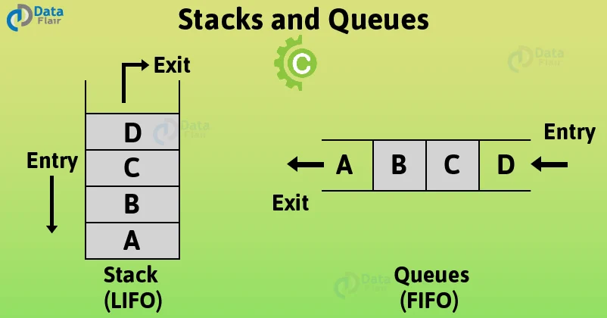
A stack in C is nothing but a linear data structure that follows the LIFO rule (Last In First Out). In a stack, both insertion and deletion take place from just one end, that is, from the top.
In contrast to a stack, a queue in C is nothing but a linear data structure that follows the FIFO rule (First In First Out ). Insertion is done from the back (the rear end) and deletion is done from the front.

Data structures
Please use the following data structures for this project. Don’t forget to include them in your header file.
/**
* struct stack_s - doubly linked list representation of a stack (or queue)
* @n: integer
* @prev: points to the previous element of the stack (or queue)
* @next: points to the next element of the stack (or queue)
*
* Description: doubly linked list node structure
* for stack, queues, LIFO, FIFO
*/
typedef struct stack_s
{
int n;
struct stack_s *prev;
struct stack_s *next;
} stack_t;

/**
* struct instruction_s - opcode and its function
* @opcode: the opcode
* @f: function to handle the opcode
*
* Description: opcode and its function
* for stack, queues, LIFO, FIFO
*/
typedef struct instruction_s
{
char *opcode;
void (*f)(stack_t **stack, unsigned int line_number);
} instruction_

Requirements
- Ubuntu 14.04 LTS
- all .c files pass Betty style: betty-style.pl and betty-doc.pl
- maximum of one global variable
- no more than 5 functions per file
- prototypes of all functions are included in header file called monty.h
- all header files are include guarded
- allowed to use standard library
functions used

push : pushes an element to the stack.

Pall : prints all the values on the stack, starting from the top of the stack.

Pint : prints the value at the top of the stack followed by a new line.

pop : removes the top element of the stack.

Swap : swaps the top two elements of the stack.

Add : adds the top two elements of the stack. The answer is stored in the second top element of the stack and the top element is removed so that the top element contains the result and the stack is one element shorter.

Sub : subtracts the top element of the stack from the second element of the stack. The answer is stored in the second top element of the stack and the top element is removed so that the top element contains the result and the stack is one element shorter.

Div : divides the second top element of the stack by the first element of the stack. The answer is stored in the second top element of the stack and the top element is removed so that the top element contains the result and the stack is one element shorter.

mul : multiplies the top two elements of the stack. The answer is stored in the second top element of the stack and the top element is removed so that the top element contains the result and the stack is one element shorter.

mod : computes the remainder of the division of the second top element of the stack by the top element of the stack. The answer is stored in the second top element of the stack and the top element is removed so that the top element contains the result and the stack is one element shorter.

